A Portrait of the Artist as a Young Man

Links: http://faculty.gvsu.edu/websterm/portrait.htm  From Brandon Kershner's Portrait Page:  http://users.clas.ufl.edu/kershner/port.html  • "Early Years" and  • "Parnell and Irish Nationalism" (scroll down)  • "Schooldays" and  • "The Irish Literary Renaissance" (scroll down)  • "University Influences"  • "Flight to Europe"  • "Early Reviews"  Biography of Charles Stewart Parnell  Biography of Francis Sheehy-Skeffington ("McCann")  A 1916 Review of Portrait by H. G. Wells  Easter 1916 Postcards  James Joyce Links (ENG 383 Links page)  Epiphanies | 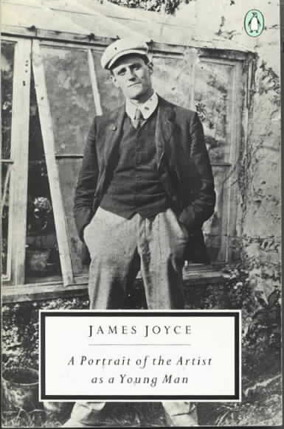
Notes, Chapter I
epigraph: Et ignotas animum dimittit in artes = "And he applies his mind (spirit) to unknown arts" [the line continues, "and changes the laws of nature."] A description of the master-craftsman Daedalus planning to escape the island of Crete. He escaped by making wings of feathers held together by wax and string. His son, Icarus, flew too close to the sun, which melted the wax, causing Icarus to fall to his death in the Icarian Sea.
(3) a glass = a monocle; Dante, character based on Mrs. "Dante" ("Aunt") Hearn Conway, governess in the Joyce household.
(3-4) Davitt is Michael Davitt (1846-1906), Irish revolutionist who founded the Land League, which aimed to make Ireland socialist. Parnell is Charles Stewart Parnell (1846-1891), member of (the British) Parliament, and "Chief" of the Irish nationalist movement until he was named an adulterer in 1889.
(4) cachou candy and breath freshener; the third line = boys under 13. There are two other "lines" as well: the "lower" (boys 13-15) and "higher" (boys 15-18). greaves in his number and a hamper in the refectory = Shinguards in his locker and a private supply of food in the dining hall.
(6) peach on = to tell on, to rat on. soutane = black priest's gown with sleeves. Hamilton Rowan . . . haha--Rowan was an Irish patriot who fled to the castle (later Clongowes Wood College) after his conviction in 1794 for sedition. As part of his escape, he threw his hat as a decoy on the haha, "a fence or hedge or wall set in a ditch."  (7) square ditch = The square was the name for an open latrine behind the college; the ditch is a slate trough running diagonally across the "square." McGlade's suck = A suck-up or brown-nose to a teacher named McGlade. | 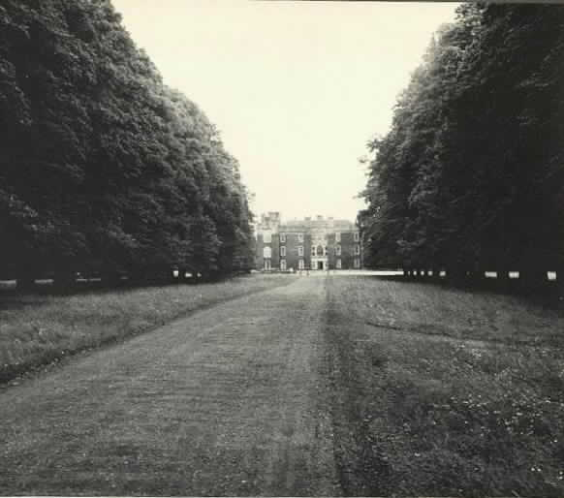  Clongowes Wood College
(8) York and Lancaster were two English houses (noble families) opposed in the War of the Roses (1445-85). Father Arnall has divided the students into two competing groups: as champion of the York group, Stephen wears the white rose (or ribbon).
(9) elements = English, math, geography, history, Latin.
(13) a cod = a joke.
(15, 17) the cars = hackney carriages hired to take the boys to the railway station, some 3-4 away at Sallins. My sources tell me the word "car" derives from Old Irish.
(22) a cope of black and gold = long vestment characteristic of funeral masses.
(25) Parnell! He is dead! Parnell died in October, 1891.
(26) toasted boss = a footstool. pierglass = long mirror.
(26) a birthday present for Queen Victoria--Mr. Casey is modeled on a friend of Joyce's father who had been imprisoned several times for Land League agitation. His fingers were permanently cramped from picking oakum in prison. (Oakum is a loose hemp or jute fiber used for caulking seams of ships.) ozone round the Head = Bray Head, overlooking the town of Bray (near Dublin) where Stephen's family lives.
(28) pandybat = a stiff, reinforced leather strap used to punish disobedient students.
(29) a pollingbooth--many priests preached against Parnell after it was revealed that the "Chief" of the Irish nationalist movement was an adulterer. Eventually, pressure from the Irish and English public, from his own party, and from Davitt (head of the Land League) and Gladstone (British Prime Minister) forced Parnell to resign his post as head of the Irish Home Rule faction in Parliament. Before he fell from power, Parnell was very near to swinging a deal with Gladstone for Home Rule for Ireland.
(32) Billy with the lip . . . tub of guts = Archbishop William Walsh of Dublin and Michael Logue, bishop of Armagh.
(35) The Paris Funds! Mr. Fox! Kitty O'Shea! Parnell was accused of misappropriating some party funds; he used the pseudonym of Mr. Fox in his adulterous liaison with Mrs. Katherine O'Shea.
(37) a whiteboy = member of a sometimes terrorist group who agitated against unjust landlords of tenant farmers. Joyce's great-grandfather actually was condemned to death as a whiteboy, but the sentence was never carried out.
(40) fecked = stole. scut = took off, cleared out.
(41) boatbearer = the server who carries the container of incense before it is lighted. sprinter = short distance bicycle racer.the prof = captain of the cricket team.
(42) Smugging = slang for "a mild form of homosexual petting."
(43) Calico Belly = Caesar's Bello Gallico or the Gallic War, a common school Latin text.
(44) six and eight = number of blows given with the strap as punishment. ferulae = strokes [Latin].
(47) monstrance = a gilded vessel designed to display the host.
(57) saint Ignatius Loyola (1491-1556) founder of the Jesuit Order of priests.
(57) Ad Majorem Dei Gloriam = "For the Greater Glory of God, the Jesuit motto [Latin]. One of my sources notes that the cruelty of Stephen's school "does not approach" that (recorded by British writers like C. S. Lewis and George Orwell) of English schools like Eton and Harrow. After all, Stephen does receive justice from the rector, and "other masters are represented as kindly men."
Questions, Chapter I
Why do you suppose Joyce writes the first chapter as he does? (Think of point of view, the lack of exposition, etc.) What does he gain and lose by employing such a method?
What indications do you find in the first two chapters that Stephen Dedalus will grow up to be an artist? In what ways can you connect the many images of water and fire, wet and dry, and cold and warm that appear in chapter I?
Can you name any ways in which the young Stephen is like Parnell? Why do you think Joyce juxtaposes Stephen's imagined death with Parnell's death (22-25)? As you read the book, try to figure out how Joyce views the artist's relation to politics.
Why do you think Joyce included the Christmas dinner scene? Why do you think he follows this scene with various examples of transgression and punishment at Clongowes?
How is authority (particularly the Catholic Church and the British Empire) depicted in the first two chapters? Why do you think Joyce stresses the importance of Stephen's visit to the rector (53-61)?
The 9-year old James Joyce wrote a poem on Parnell's death called "Et tu, Healy." (Tim Healy was Parnell's trusted lieutenant who turned against him when the Chief's adultery was discovered.) Why do you think Joyce barely mentions this poem (on p. 73) in A Portrait?
Notice how separate the world of men and boys is from the world of women and girls. What do you think women symbolize for Stephen? (Don't forget the Virgin Mary.)

Notes, Chapter II
(65) Mercedes = not an expensive car, but a woman beloved by the Count of Monte Cristo and stolen away from him by four bad guys who falsely imprison him. Returning some 15 years later to take his revenge, he utters the line about muscatel grapes to Mercedes, who has in the meantime married one of the bad guys.
(67) caravans = covered horse-drawn carts or moving vans.
(71) Josephine = name of Stephen's (and James Joyce's) favorite aunt, who was reading the paper in the epiphany on the previous page. crackers = exploding party favors.
(72) tram = a streetcar, probably horse-drawn.
(73) A.M.D.G. = "Ad Majorem Dei Gloriam" [Latin] = "For the greater glory of God," Jesuit motto. E___ C____ = "Emma Clery," a character who is described in full only an earlier version of the story called Stephen Hero.
second moiety notices = the second request by the city for taxes.
(74) L.D.S. = "Laus Deo Semper" [Latin] = "Praise God Always," put at the end of school compositions.
christian brothers: another order of priests, less prestigious than the Jesuits.
(76) Whitsuntide = beginning of the week of the Pentecost, 7th Sunday after Easter.
(82) Confiteor = prayer recited as preparation for confession.
(83) heresy Stephen's heresy involves the granting of adequate grace.
(93) in a jingle = in a horse-drawn car.
(94) come-all-yous = Irish street ballads, usually beginning with the words, "O, come all you . . ." See p. 34.
(96) a free boy = a scholarship student.
(100) Tempora mutanur . . . illis = "Circumstances change and we change with them." Both versions are grammatically correct, the second metrically correct.
(102) Shelley's fragment = "To the Moon."
Questions, Chapter II
In what ways do you think Stephen is "different from others" (67)? What do you think is the "insubstantial image" mentioned on p. 67? In what ways can you relate this passage to the one on words on p. 64?
Why do you think Joyce includes Simon Dedalus' version (75-76) of the pandybat episode?
Why do you think Stephen defends Byron against Heron and the others (84-87)? What differences can you discern between Stephen's approach to literature and his tormentors' approach? Is this what you used to argue about when you were 12-13 years old?
Compare Simon's come-all-you (93) with Stephen's fragment of Shelley (102). What do you think are the effects of each poem on each person?
Compare / contrast the endings of chapters 1, 2, 3, and 4. What do you think Joyce wants to show with each ending? In what ways is Stephen free / unfree in each?

Notes, Chapter III
(111) sanctifying grace = "the state of habitual holiness, as distinguished from actual grace, the temporary help to act morally."
(112) Quasi cedrus . . . suavitem odoris = "I was exalted like a cedar in Libanus, and as a cypress tree in Mount Sion. I was exalted like a palm tree in Cades and as a rose plant in Jericho. As a fair olive in the plains, and as a plane tree by the water in the streets, I was exalted. I gave a sweet smell like cinnamon and aromatic balm: I gave a sweet odor like the best myrrh." From Ecclesiasticus 24:17-20, a book that is in the Catholic Bible, but not in the Bibles of other traditions. (It is called "Sirach" in the Apocrypha.) The contrast between the text and Stephen's spiritual and mental state should be obvious.
(114) retreat = communal withdrawal from the world to reflect on the spiritual life.
(125) Emma = Emma Clery.
(126) non serviam = the devil's sin of pride; remember this when you get to p. 260.
(158) ciborium = metal vessel shaped like a large wine cup that holds communion hosts. Corpus Domini nostri = "the body of our Lord"; In vitam eternam = "unto life eternal."
Questions, Chapter III
In what ways are the "curious questions on pp. 113-114 like and unlike the aesthetic questions which Stephen later propounds to himself and his friends?
Why do you think Stephen repents? Do you think the repentance will last?
What connections can you make between Stephen's views of women (virgin / whore) and his eventual voctation as an artist?
Notice how many times Stephen is asked to confess or "admit" or "apologise" (4) in the novel. What do these moments of confession have in common? How are they different? How is confession like / unlike creating an artwork?
Notes, Chapter IV
(159) supererogation = acts beyond the requirements of duty to establish a reservoir of merit.
(160) chaplets = the 3 divisions of the cycle of prayers called a rosary.
(161) unseen Paraclete = the Holy Ghost.
(163) twigging of the carpet = sweeping the carpet with a small brush.
(164) canticles = Song of Solomon. Inter ubera . . . = "He shall lie between my breasts" (Song of Solomon, 1:13).
(167) Les jupes = "the skirts." / (170) a vocation = calling to the priesthood.
(171) thurible = incense burner; chasuble = long outer vestment worn by priest when saying mass.
(172) humeral veil = veil covering shoulders; paten = plate on which communion hosts (pieces of bread) are placed; Ite, missa est = Go, the mass is ended.
(178) the Bull = a seawall, not a pub.
(181) seventh city = Dublin; thingmote = place where Danes held council of law when they ruled Dublin in medieval times.
(182) Stephanos! = "crown, wreath, garland" [Greek]. Bous Stephanomenos! Bous Stepnanophoros! = Greek variants for "ox bearing wreaths" [i.e., before being led to the sacrifice], or "ox- or bull- soul of Stephen."
(183) fabulous artificer = Daedalus, fabled master-craftsman of Greek myth.
(184) Howth = Howth Head, a headland on the sea northeast of Dublin.
Questions, Chapter IV
What do you think attracts Stephen to the priesthood? Why do you think he rejects it? In what ways is his later vocation (or "calling") as an artist like and unlike that of a priest? In what ways does Stephen himself become the host, the sacrifice?
In what ways is Stephen's problem one of figuring out how to "encounter reality"?
As an artist, what or who will Stephen serve? Who or what calls Stephen to the life of an artist?
If art is equated with life at the end of chapter IV, what sort of life is it?
Why do you suppose creation is associated with women, love, and (possibly) lust? (See pp. 72-74, 81, 110, 182-187, 235-243, 275-76.) In what ways is Stephen's initiation into sex like / unlike his emerging vocation / identity as an artist? (See pp. 67, 106-108.)
Why do you think Stephen is finally unable to "obey the word of His [Christ's] church" (128)?

Notes, Chapter V
(190) sloblands of Fairview = trashy area of tidal flatland; waistcoateers . . . chambering = prostitutes engaging in lewd activities [both Elizabethan terms].
(191) Synopsis . . . = "Synopsis of Scholastic Philosophy for Understanding St. Thomas [Aquinas]."
(193) India mittit ebur = "India sends ivory."
(194) Contrahit orator, . . . = "The orator summarizes, the poet (or prophet) amplifies (or transforms)." in tanto discrimine= "in such a crisis"; implere ollam denarorium = to fill the jar with denarii [Roman coins]. national poet = Thomas Moore (1779-1852), writer of romantic songs, friend of Byron. His statue stands in front of Trinity College, the university open at that time to Protestants only. Firbolg . . . Milesian = legendary ancient inhabitants of Ireland, "the former dwarfish and primitive, the latter tall and handsome."
(195) Michael Cusack = founder of the Gaelic Athletic Association. fenian = party in Ireland that believed in armed struggle against the British, officially called the Irish Revolutionary Brotherhood. See p. 38. cycles = cycles of Irish myths.
(196) tame geese—Irish expatriates were called "wild geese." hurling match = hurley, an ancient Irish game like lacrosse;minding cool = keeping goal.
(199) Wolfe Tone = Theobald Wolfe Tone (1763-1798), Irish patriot, founder of United Ireland, and leader of 1798 revolt. The slab was placed 100 years later. brake = scaffold.
(201) Pulchra sunt quae visa placent = That is beautiful which pleases the eye. Bonum est in quod tendit appetitus = That is good towards which the appetite tends.
(201) Similiter atque senis baculus = Like an old man's walking stick. The quote is from the "founder," Ignatius Loyola, founder of the Jesuit order.
(202) Epictetus = Greek Stoic philosopher whose name means "acquired" (i.e., a slave), and who was also lame.
(206) Per aspera ad astra = By rough ways to the stars (a cliché).
(210-11) Ego habeo—The Latin dialogue on these pages translates as: "I have." "What?" "For universal peace." "I think you are a bloody liar because your face shows you are in a damned bad humour." "Who is in bad humour, you or I?"
a sugar! = either "a shit" or "a hopeless case."
(214) Pax super . . . globum = "Peace over the whole bloody globe."
(215) Nos ad manum . . . = "Let's go play handball."
(218) a criticism of life —Victorian poet and critic Matthew Arnold said that "Poetry is a criticism of life." Long pace, fianna! = marching orders from the secret drillbook of the Fenians.
(221) pity and terror Aristotle says in his Poetics that tragedy gives rise to the emotions "of pity and fear" thus "completing the purification [catharsis, sometimes translated "purgation"] of such emotions."
(227) Pange lingua gloriosi = "Tell, my tongue, of the glorious [body of Christ]"—opening line of a hymn by Aquinas.Vexilla Regis = "The Banners of the King [Advance]." The second stanza of the hymn on the next page translates: "Fulfilled is all that David told / In true prophetic song of old: / Amidst the nations, God, saith he, / Hath reigned and triumphed from the Tree."
(229) Laocoon = 1766 treatise by Gotthold Ephraim Lessing on the differences between the visual and verbal arts. TheLaocoon is a "group of statues" (232) depicting Laocoon, a priest of Troy, and his two sons struggling with the serpents who will devour them. See Virgil's Aeneid, book 2.
(231) claritas might better be translated as "clarity."
(234) Ego credo . . . = "I believe that the life of the poor is simply atrocious, simply bloody atrocious, in Liverpool."
(236) seraphim = highest order of angels. villanelle = difficult French verse form used by Stephen to write his poem.
(244) ashplant . . . stick of an augur = a cane made of ash wood, said to resemble the stick of a professional Roman prophet.  (245) Bend down your faces —Spoken by the dying Countess in Irish poet W. B. Yeats' play The Countess Cathleen. She has sold her soul to the devil to save those of her peasants. The play was booed "the night of the opening," but Joyce "clapped vigorously." The next day, he refused to sign a letter protesting the play's supposedly anti- Irish and anti-religious content.  (250) Pernobilis et pervetusta . . . = "a very noble and ancient family." | 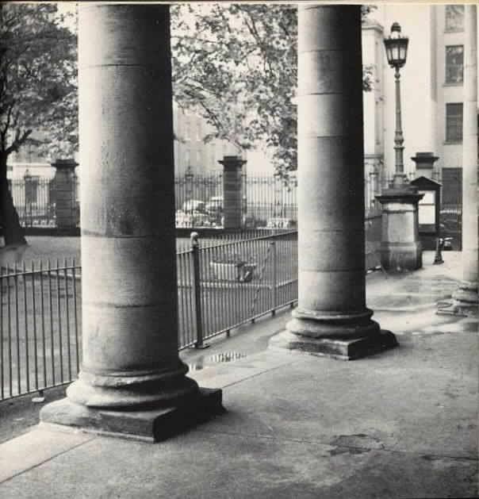  The Library Porch
(253) Darkness . . . Stephen misquotes a line from Thomas Nashe's "A Litany in Time of Plague" (1592). See page 254. The entire stanza reads: "Beauty is but a flower / Which wrinkles will devour; / Brightness falls from the air; / Queens have died young and fair; / Dust hath closed Helen's eye. / I am sick, I must die. / Lord, have mercy on us!" Note that Lucifer ("light-bringer") also fell.
(265) Mulier cantat = "A woman sings."
(266) Et tu cum Jesu Galilaeo eras = "And you were with Jesus of Galilee" (Matthew 26:69; said to Peter before he denies knowing Christ). proparoxyton = Latin word having an acute accent on the second to the last syllable (here, "-lae" inGalilaeo).
(271) B.V.M. = "Blessed Virgin Mary."
(273) the shortest way to Tara = Tara is a hill where ancient Irish kings used to meet, thus a symbol of Irish nationhood; Holyhead is the port in Wales where the boat from Dublin docks. In other words, to find Ireland, you have to leave Ireland.Michael Robartes remembers —a symbolist poem by W. B. Yeats.
Questions, Chapter V
Why do you think Joyce creates such a contrast of tone and mood between the end of chapter IV and the beginning of chapter V?
What do you think is the artistic and political significance of the discussion of the tundish (204-205)? (See also p. 274.) In what ways can you relate this discussion to the larger discussion of art and beauty, "the esthetic question" (202)?
Why do you think Stephen refuses to sign the petition for world peace? What would you say is his attitude towards politics in general and Irish politics in particular? Do you think it has changed much since chapter I? Why or why not?
What do you like / dislike about Stephen? Do you think the author wants us to like him?
Why do you think Stephen is so concerned to define what art and beauty are and what their effects are? Why do you think the artist's personality should be refined "out of existence" (233)? How do his definitions fit or not fit with the aesthetic aims of realists, naturalists, symbolists, and aestheticists? What is the point of Stephen's art?
Is Stephen's villanelle lyric, epic, or dramatic? Would you say that A Portrait is lyric, epic, or dramatic? Do you think it illustrates any of his theories? (If so, in what ways?) How would you interpret this poem? (Note the use of religious language to describe and praise a presumably virtuous Irish woman who is nevertheless depicted as a femme fatale.)
In what ways can you connect the metaphor of a "Portrait" with Joyce's narrative style in the book?
What reasons does Stephen give for leaving? Why do you think his vision of art is so at odds with living a normal life in his society?
What do you think Stephen means when he says he will "forge . . . the uncreated conscience of my race" (276)? (See pp. 110, 198.)

Epiphanies
By an epiphany he meant a sudden spiritual manifestation, whether in the vulgarity of speech or of gesture or in a memorable phrase of the mind itself. He believed that it was for the man of letters to record these epiphanies with extreme care, seeing that they themselves are the most delicate and evanescent of moments. He told Cranly that the clock on the Ballast Office was capable of an epiphany. . . .
"Claritas is quidditas. After the analysis which discovers the second quality the mind makes the only logically possible synthesis and discovers the third quality. This is the moment which I call epiphany. . . . Its soul, its whatness, leaps to us from the vestment of its appearance. The soul of the commonest object, the structure of which is so adjusted, seems to us radiant. The object achieves its epiphany . . . ." (Stephen Hero 223-224)

