An Introduction to Drama as Literature

The Tragical History of Doctor Faustus
A.P. ENGLISH LITERATURE & COMPOSITION

Aristotle’s Definition of Tragedy

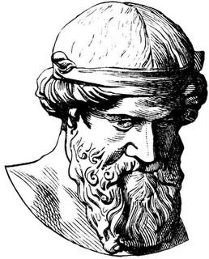
Aristotle was born in Stagirus, Macedonia, Greece in 384 BC and died 62 years later in 322 BC. He was a student at Plato's Academy and later became one of the greatest philosophers of Ancient Greece. In one of his treatises, The Poetics, he outlines the Six Elements Of Drama, based on the Ancient Greek belief that tragedy was the highest form of drama. This outline has become a guideline for many playwrights throughout history, and is especially emphasized in the works of William Shakespeare. Here is Aristotle’s definition:

“A tragedy is the imitation of an action that is serious and also, as having magnitude, complete in itself; in appropriate and pleasurable language;... in a dramatic rather than narrative form; with incidents arousing pity and fear, wherewith to accomplish a catharsis of these emotions.”

Aristotle’s Six Elements of Drama

1. Plot – what happens in a play; the order of events, the story as opposed to the theme; what happens rather than what it means.

2. Theme – what the play means as opposed to what happens (plot); the main idea within the play.

3. Character – the personality or the part an actor represents in a play; a role played by an actor in a play.

4. Diction/Language/Dialogue – the word choices made by the playwright and the enunciation of the actors delivering the lines.

5. Music/rhythm – by music Aristotle meant the sound, rhythm and melody of the speeches.

6. Spectacle– the visual elements of the production of a play; the scenery, costumes, and special effects in a production.

The Modern Elements of Drama

In modern theater, the Elements of Drama have changed only slightly, although you will notice that many of the elements remain the same. The list of essential elements in modern theater are: Character, Plot, Theme, Dialogue, Convention, Genre, Audience.

The first four -- character, plot, theme and dialogue -- remain the same as Aristotle’s list, but the following additions are now also considered essential elements of drama.

5. Convention: These are the techniques and methods used by the playwright and director to create the desired stylistic effect.

6. Genre: Genre refers to the type of play. Some examples of different genres include, comedy, tragedy, mystery and historical play.

7. Audience: This is the group of people who watch the play. Many playwrights and actors consider the audience to be the most important element of drama, as all of the effort put in to writing and producing a play is for the enjoyment of the audience.

Like fiction, drama features characters facing a conflict that sparks a sequence of events organized by the plot. The conflict reaches a climax, or point of greatest intensity, before being solved in the resolution at the end. Unlike fiction, however, a drama is a story written to be performed by actors speaking dialogue, the characters’ words, rather than by a narrator.

Acts and Scenes are the basic divisions of drama. A drama may consist of one or more acts, each of which may contain any number of scenes.

The script, or text, of a play contains dialogue and stage directions. Dialogue is the words the characters say. Stage directions are notes telling how the work is to be performed or staged. Directions are often printed in italics and set off in brackets.

Sets are the constructions indicating where the scene takes place. A set may include such items as painted backdrops and wooden frames.

Props are moveable objects, like a spear or a cup, that actors use onstage.

In performance, these various elements of drama combine to produce the illusion of reality known as dramatic effect. Through this effect, the dramatist explores a theme, or central message about life.

Types of Drama
The ancient Greeks developed drama, creating two basic types of plays:

I. Tragedy
A tragedy shows the downfall or death of the tragic hero, or main character. In ancient Greek drama, the hero was an outstanding person brought low by a tragic flaw, a mistaken action, defect, or vice of a character. A chorus, or group of performers, sang, danced, and commented on events. The hero’s downfall was meant to bring about a catharsis, or calming release of tension, in the audience.

William Shakespeare’s tragedies differ from Greek tragedies in several ways. In Shakespearian tragedy, the hero has greater free will, or power of choice, and reveals more of an inner life. There is no formal chorus, but one or more characters may comment on the action. Patterns of imagery, or sensory language, reinforces themes.

II. Comedy
In contrast to tragedy, a comedy ends happily after an amusing series of predicaments. If tragedy senses human greatness, comedy emphasizes human faults and the weaknesses of society itself.

Types of Dramatic Speech
In addition to dialogue involving conversations between two or more characters, dramatists use these types of dramatic speech:

Monologue: a character speaks at length to silent listeners

Soliloquy: a character alone on stage reveals private thoughts to the audience

Aside: a character briefly expresses private thoughts to the audience that other characters on stage cannot hear.

How to Read a Play
When you think about a play, you probably think about going to watch the drama being acted out upon the stage, but plays are first written down by the playwright as scripts. The dramatic and verbal aspect of a play is very important, but you can also enjoy reading it. Here's how to read and enjoy a play.

1. Pre-Read: Read any criticism or introduction included in the publication you are studying. They will suggest ideas and approaches to interpreting the play that you may find helpful later. Read them a second time when you've finished reading the play.

2. Identify Genre: Find out the genre of the play; that is, whether it's a tragedy, a comedy, a romance, a satire, etc. You will then know how the play will most likely end.

3. Count the Acts: Determine how many acts the play has. That will give you clues about what should be happening in each part. Generally, a traditional play will set the scene (exposition), introduce a problem (conflict), follow that problem to its logical conclusion, reach the final conflict (climax) and then offer a resolution. This could happen in anywhere from one to five acts.

4. Get to Know the Characters: Write up a chart of characters and how they are related to one another, particularly if it is a play with representatives from several social strata: keep in mind, for example, who is a king and who is merely a minor duke.

5. Try to Summarize Plot: Write short summaries of the action as you are reading through it; some plays depend on very intricate, twisted plots to reach their resolutions.

6. Visualize the Drama: Imagine costumes, sets, noises and times of day/night as you read.

7. Read Aloud: Read as much as you can of the play aloud; it will help you decide what the character's tone and attitude is.

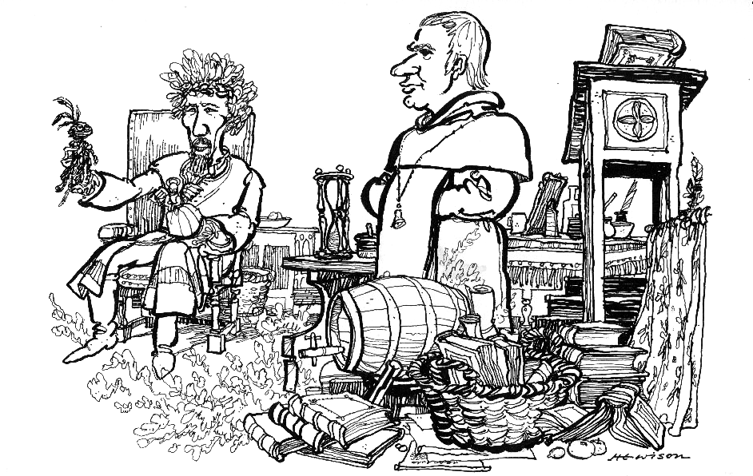

Was this the face that launch’d a thousand ships, / And burnt the topless towers of Ilium? / Sweet Helen, make me immortal with a kiss! / Her lips suck forth my soul: see, where it flies!
—Doctor Faustus.

Elizabethan Drama

Popular drama had its beginnings in England with the miracle, mystery, and morality plays of the Middle English times. But it wasn’t until the late 16th century that drama became a literary art form.

Despite being one of the most horrible despots in the history of the Western world, Queen Elizabeth I was a strong supporter of the arts. It was during her reign (1558-1603) that drama flourished in England. During her reign, some playwrights were able to make a comfortable living by receiving royal patronage. There was a great deal of theatrical activity at Court, and many public theatres were also built on the outskirts of London.

Theatre was a popular pastime, and people of all walks of life attended. Although women were not allowed onstage, they did attend performances and often made up a substantial part of the audience. The theatre also drew many unsavory characters, including pickpockets, cutpurses, and prostitutes. Because of the perceived bad influence of the theatres, the Puritans were vocally opposed to them and succeeded in shutting them down in 1642.

Some of the most important playwrights come from the Elizabethan era, including William Shakespeare, Ben Jonson, and Christopher Marlowe. These playwrights wrote plays that were patterned on numerous previous sources including the Greek tragedy, Seneca's plays, Attic drama, English miracle plays, morality plays, and interludes. Elizabethan tragedy dealt with heroic themes, usually centering on a great personality who is destroyed by his own passion and ambition. The comedies often satirized the fops and gallants of society. The characters, however, were of native origin, and reflected the spirit and the interests of the Englishmen of that day.

In Elizabethan drama the dialogue was written in verse. All of Shakespeare’s plays – except a few comic scenes done in prose – are written in unrhymed iambic pentameter lines. Some scenes close with a rhymed couplet.

Three types of Elizabethan dramas prevailed:

I. The Chronicle History

Of the various forms which this drama took, the first to reach a culmination was the so-called Chronicle History. This is represented by the Edward II by Christopher Marlowe, the greatest of the predecessors of Shakespeare; and Shakespeare himself produced some ten plays belonging to the type. These dramas reflect the interest the Elizabethans took in the heroic past of their country, and before the vogue of this kind of play passed, nearly the whole of English history for the previous three hundred years had been presented on the stage.

As a form of dramatic art, the Chronicle History had many defects and limitations. The facts of history do not always lend themselves to effective theatrical representation, and in the attempt to combine history and drama both frequently suffered. But surprisingly often the playwrights found opportunity for such studies of character as that of the King in Marlowe’s tragedy, for real dramatic structure as in Shakespeare’s Richard III, or for the display of beautiful rhetoric and national exultation as in Henry V.

II. Elizabethan Tragedy

Closely connected with the historical plays was the early development of tragedy. In the search for themes, the dramatists soon broke away from fact, in favor of imaginative narrative. While the work of Seneca accounts to some extent for the prevalence of such features as ghosts and the motive of revenge, the form of tragedy that Shakespeare developed from the experiments of men like Marlowe was really a new and distinct type. Such classical restrictions as the unities of place and time, and the complete separation of comedy and tragedy, were discarded, and there resulted a series of plays which, while often marked by lack of restraint, of regular form, and of unity of tone, yet gave a picture of human life as affected by sin and suffering which in its richness, its variety, and its imaginative exuberance has never been equaled.

The greatest master of tragedy was Shakespeare, and in tragedy he reached his greatest height. Hamlet, King Lear, and Macbeth are among his finest productions, and they represent the noblest pitch of English genius. Of these, Hamlet was perhaps most popular at the time of its production, and it has held its interest and provoked discussion as perhaps no other play of any time or country has done. This is in part due to the splendor of its poetry, the absorbing nature of the plot, and the vividness of the drawing of characters who marvelously combine individuality with a universal and typical quality that makes them appeal to people of all kinds and races. But much also is due to the delineation of the hero, the subtlety of whose character and the complexity of whose motives constitute a perpetual challenge to our capacity for solving mysteries.

II. Elizabethan Comedy

In the field of comedy, Shakespeare’s supremacy is hardly less assured. From the nature of this kind of drama, we do not expect in it the depth of penetration into human motive or the call upon our profounder sympathies that we find in tragedy; and the conventional happy ending of comedy makes difficult the degree of truth to life that one expects in serious plays. Yet the comedies of Shakespeare are far from superficial. Those written in the middle of his career, such as As You Like It and Twelfth Night, not only display with great skill many sides of human nature, but with indescribable lightness and grace introduce us to charming creations, speaking lines rich in poetry and sparkling with wit, and bring before our imaginations whole series of delightful scenes. The Tempest does more than this. While it gives us again much of the charm of the earlier comedies, it is laden with the mellow wisdom of its author’s riper years.

Seldom in the history of the world has the spirit of a period found so adequate an expression in literature as the Elizabethan spirit did in the drama; seldom can we see so completely manifested the growth, maturity, and decline of a literary form. But beyond these historical considerations, we are drawn to the reading of Shakespeare and his contemporaries by the attraction of their profound and sympathetic knowledge of mankind and its possibilities for suffering and joy, for sin and nobility, by the entertainment afforded by their dramatic skill in the presentation of their stories, and by the superb poetry that they lavished so profusely on their lines.

Christopher Marlowe – Biographical Sketch

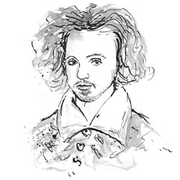
Christopher Marlowe, if he is known at all, is vaguely remembered as a playwright who wrote the immortal lines about Helen of Troy: “Was this the face that launched a thousand ships, and burnt the topless towers of Ilium?”

These lines from Dr. Faustus serve as a cliché for the soaring poetry of Elizabethan drama. Yet, Marlowe was more than a single immortal line of blank verse. He was the most popular and successful playwright before and during Shakespeare's early years, having written five tremendously successful plays. It has been suggested that he collaborated with Shakespeare on the latter's three parts of Henry VI.

Like most of the playwrights of the era (except Shakespeare), Marlowe was a university graduate (known as “university wits”), having left Cambridge in 1585, about the time of his first success, Tamburlaine. He had left Cambridge under a cloud of suspicion, accused of being a Catholic papist, and was denied his Master's degree until a letter from the Queen’s Council charged the university with granting it: “He has of late done the Queen great service.” Cambridge relented, and he became Christopher Marlow, M.A. He was born in Canterbury in 1564, the son of a shoemaker, two months before Shakespeare was born in Stratford. Besides his fame as a poet, as well as a playwright, he was, in all probability, also a spy for the queen.

A great deal of evidence exists to support this theory. Under the power of Sir Francis Walsingham, Elizabeth I had the first of the British Secret Services, and university graduates were recruited for intelligence work. The enemy, of course, was primarily Spain, but, broadly speaking, it was an intelligence war against Catholics. Sir Francis’s spy group engaged not only in intelligence gathering, but in elaborate schemes of entrapment. It was a very nasty enterprise.

In 1592 Marlowe was arrested in the Dutch town of Flushing for attempting to counterfeit coins and deliver the proceeds to assist seditious Catholics. He was sent to be dealt with by the Lord Treasurer, but no charge or imprisonment resulted. This untimely arrest may have disrupted another of Marlowe’s spying missions: by giving the resulting coinage to the Catholic cause he was to infiltrate the followers of the active Catholic plotter William Stanley and report back to Burghley.

In early May, 1593, several bills were posted about London threatening Protestant refugees from France and the Netherlands who had settled in the city. One of these, the “Dutch church libel,” written in blank verse, contained allusions to several of Marlowe's plays and was signed, “Tamburlaine.” On May 11, the Queen’s Privy Council ordered the arrest of those responsible for the libels. The next day, Marlowe's colleague Thomas Kyd was arrested. Kyd's lodgings were searched and a fragment of a heretical tract was found. Kyd asserted, possibly under torture, that it had belonged to Marlowe.

Two years earlier they had both been working for an aristocratic patron, probably Lord Strange, and Kyd suggested that at this time, when they were sharing a workroom, the document had found its way among his papers. Marlowe’s arrest was ordered on May 18. Marlowe was not in London, but was staying with Thomas Walsingham, the cousin of the late Sir Francis Walsingham, Elizabeth’s principal secretary in the 1580’s and a man deeply involved in state espionage. However, he duly appeared before the Privy Council on May 20 and was instructed to “give his daily attendance on their Lordships, until he shall be licensed to the contrary.” On May 30, Marlowe was murdered.

Various versions of Marlowe's death were current at the time. Francis Meres says Marlowe was “stabbed to death by a bawdy serving-man” as punishment for his “epicurism and atheism.” In 1917, in the Dictionary of National Biography, Sir Sidney Lee wrote that Marlowe was killed in a drunken fight, and this is still often stated as fact today.

The facts only came to light in 1925 when the scholar Leslie Hotson discovered the coroner's report on Marlowe's death in the Public Record Office. Marlowe had spent all day in a house (not a tavern, as is widely claimed, even in some biographies) in Deptford, owned by the widow Eleanor Bull, along with three men: Ingram Frizer, Nicholas Skeres and Robert Poley. All three had been employed by the Walsinghams in the Queen’s Secret Service. Witnesses testified that Frizer and Marlowe had earlier argued over the bill, exchanging “divers malicious words.” Later, while Frizer was sitting at a table between the other two and Marlowe was lying behind him on a couch, Marlowe snatched Frizer's dagger and began attacking him. In the ensuing struggle, according to the coroner's report, Marlowe was accidentally stabbed above the right eye, killing him instantly. The jury concluded that Frizer acted in self-defence, and within a month he was pardoned. Marlowe was buried in an unmarked grave in the churchyard of St. Nicholas, Deptford, on June 1, 1593.

The Faustian Bargain

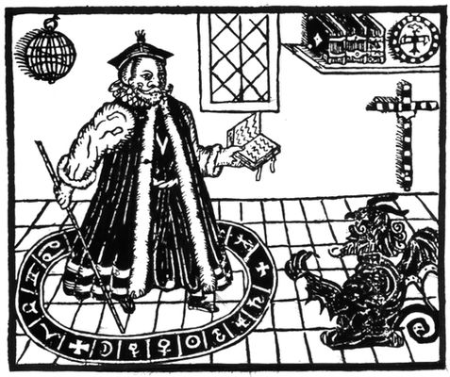
Doctor Faustus was probably written in 1592, although the exact date of its composition is uncertain, since it was not published until a decade later. The idea of an individual selling his or her soul to the devil for knowledge is an old motif in Christian folklore, one that had become attached to the historical persona of Johannes Faustus, a disreputable astrologer who lived in Germany sometime in the early 1500’s. The immediate source of Marlowe's play seems to be the anonymous German work Historia von D. Iohan Fausten of 1587, which was translated into English in 1592, and from which Marlowe lifted the bulk of the plot for his drama. Although there had been literary representations of Faust prior to Marlowe's play, Doctor Faustus is the first famous version of the story. Later versions include the long and famous poem Faust by the nineteenth-century Romantic writer Johann Wolfgang von Goethe, as well as operas by Charles Gounod and Arrigo Boito and a symphony by Hector Berlioz. Meanwhile, the phrase “Faustian bargain” has entered the English lexicon, referring to any deal made for a short-term gain with great costs in the long run.

According to traditional Christian belief in witchcraft, the pact is between a person and Satan or any other demon (or demons); the person offers his or her soul in exchange for diabolical favors. Those favors vary by the tale, but tend to include youth, knowledge, wealth, or power. It was also believed that some persons made this type of pact just as a sign of recognizing the Devil as their master, in exchange for nothing. Regardless, the bargain is a dangerous one, for the price of the Fiend's service is the wagerer's soul. The tale may have a moralizing end, with eternal damnation for the foolhardy venturer (e.g., “The Devil and Tom Walker”). Conversely it may have a comic twist, in which a wily peasant outwits the Devil (e.g., “The Devil and Daniel Webster”), characteristically on a technical point.

